S3 bucket Task Document

1.Create an S3 bucket and upload some objects to S3.
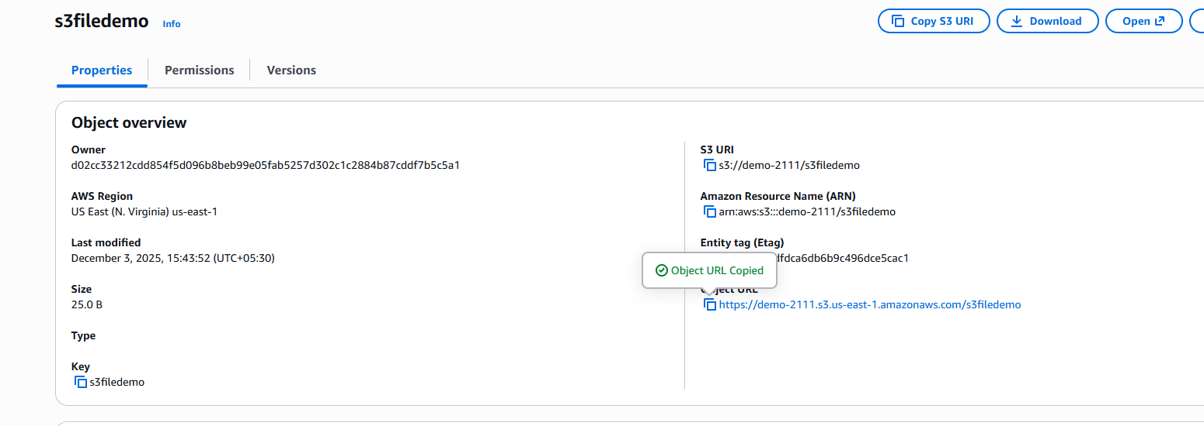
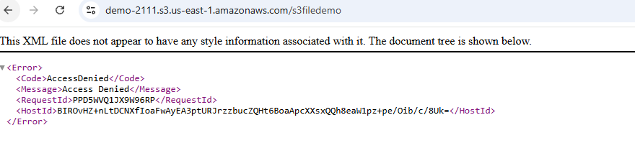
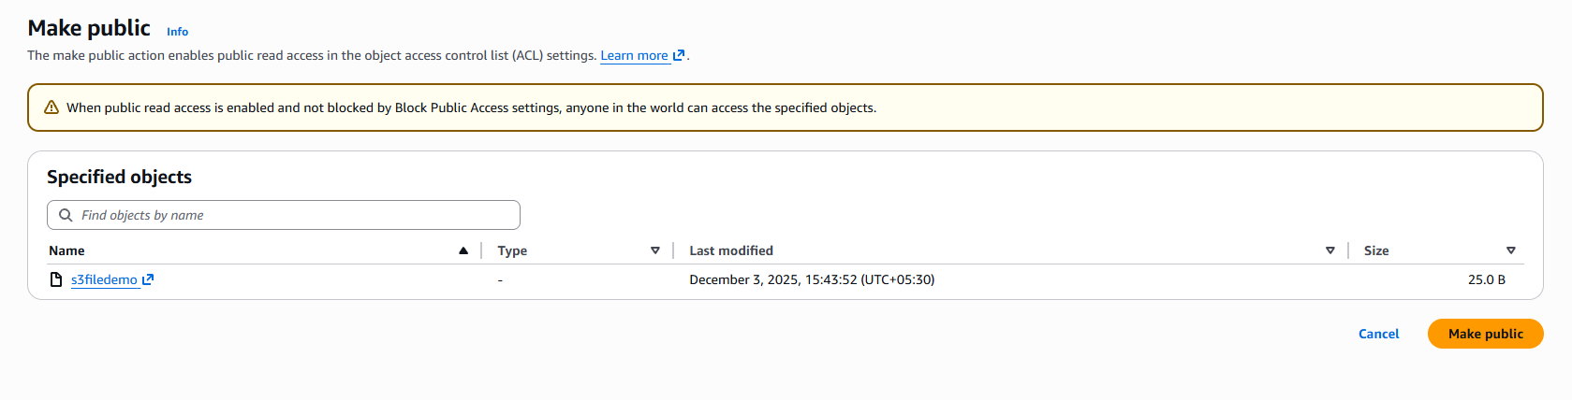
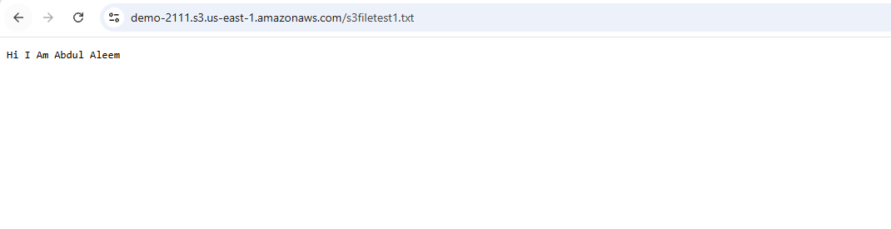

  - Deploy a static website in the S3 bucket.

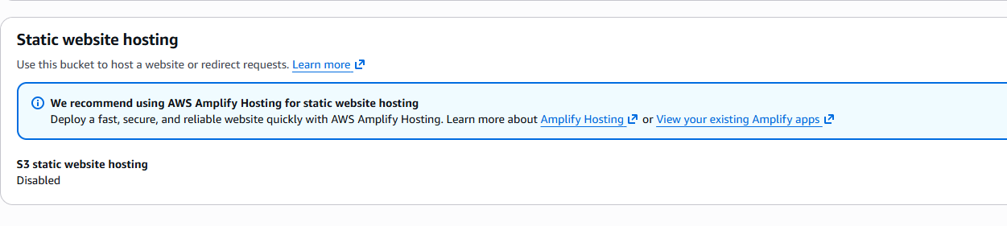
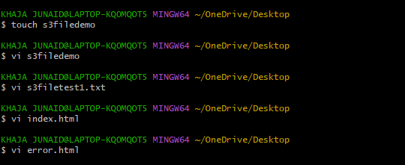
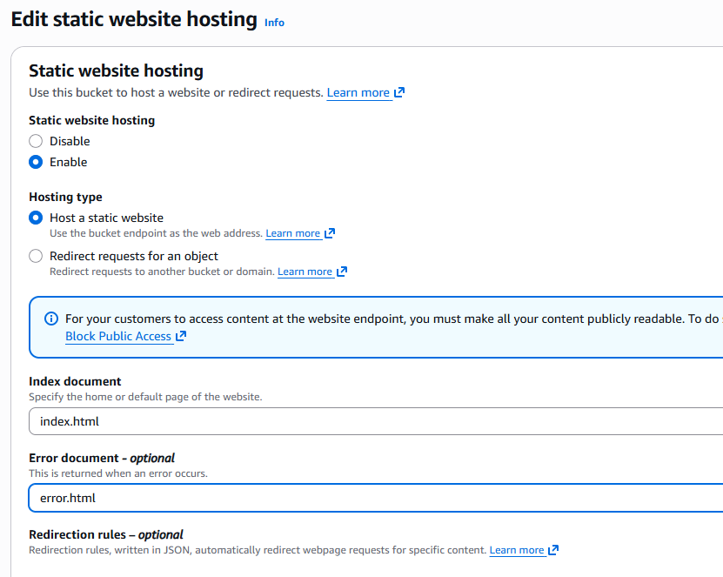

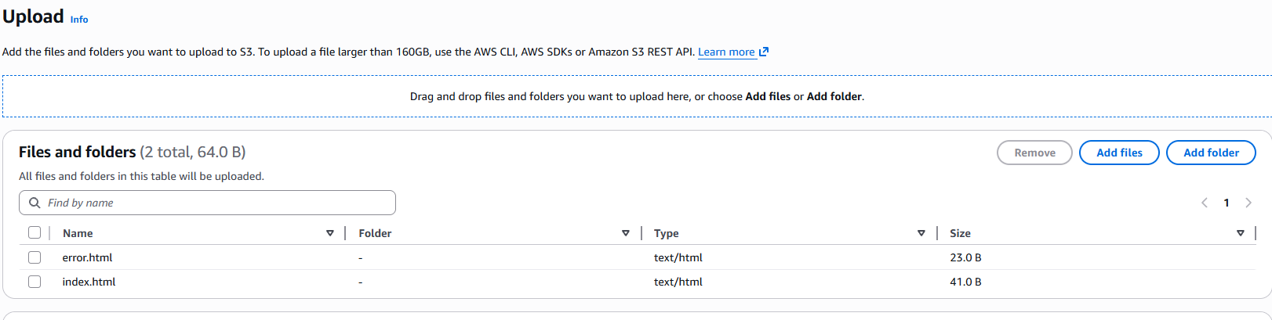
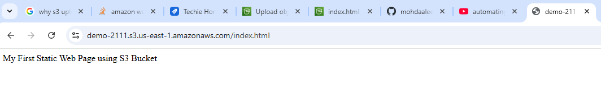
  - Enable cross-region replication on S3 buckets.
Create replication rule in another region:
Replication rules:N.virginia
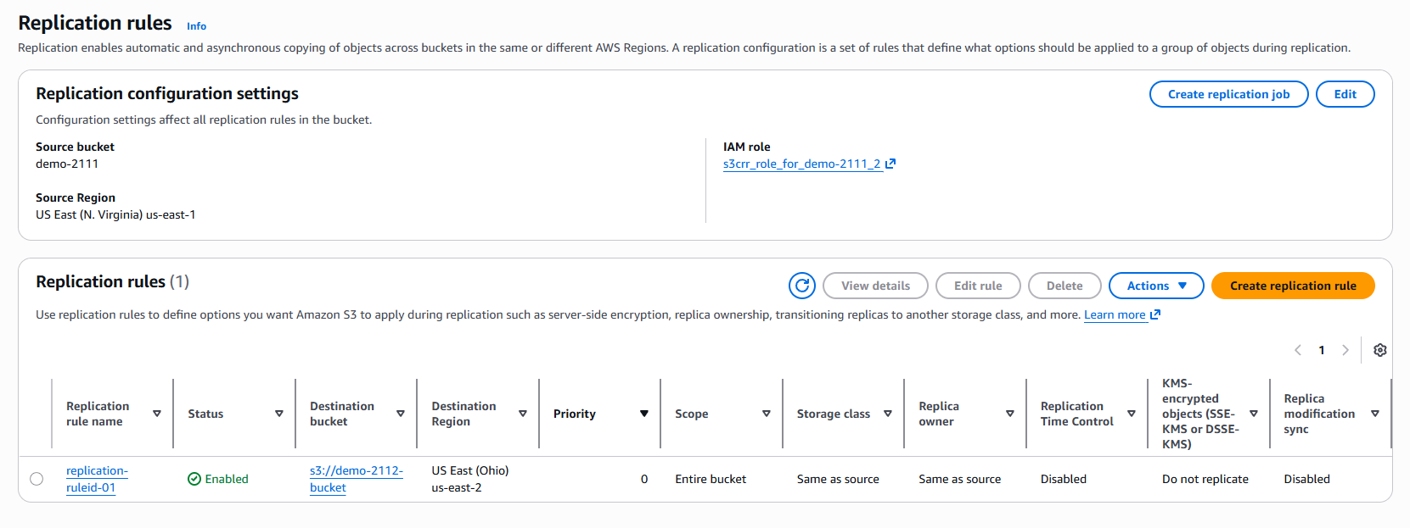
Replication rules:Ohio
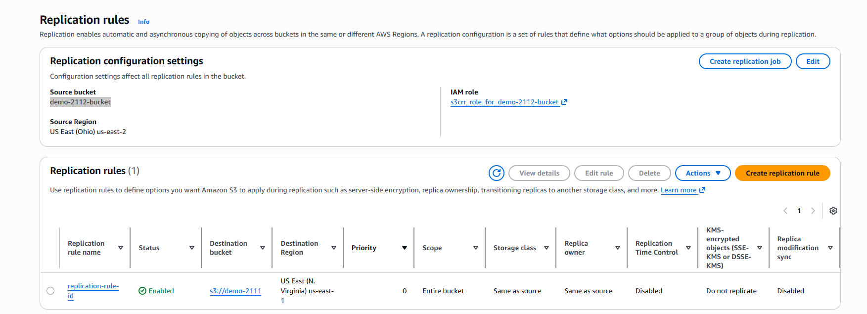

4.Configure a bucket policy so only the Admin user can see the objects of the S3 bucket.
Adding policy for IAM user:
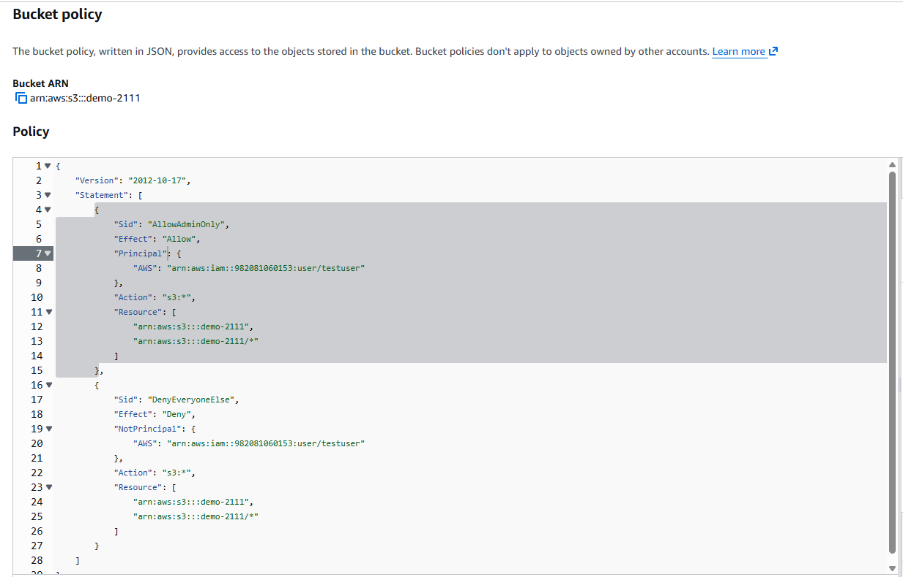
From IAM test user can access s3 bucket full access
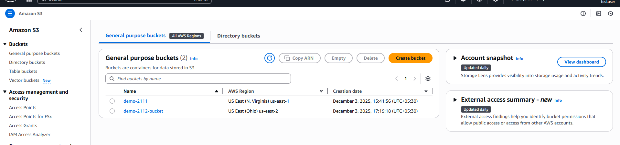

5.Set up lifecycle policies to automatically transition or delete objects based on specific criteria.

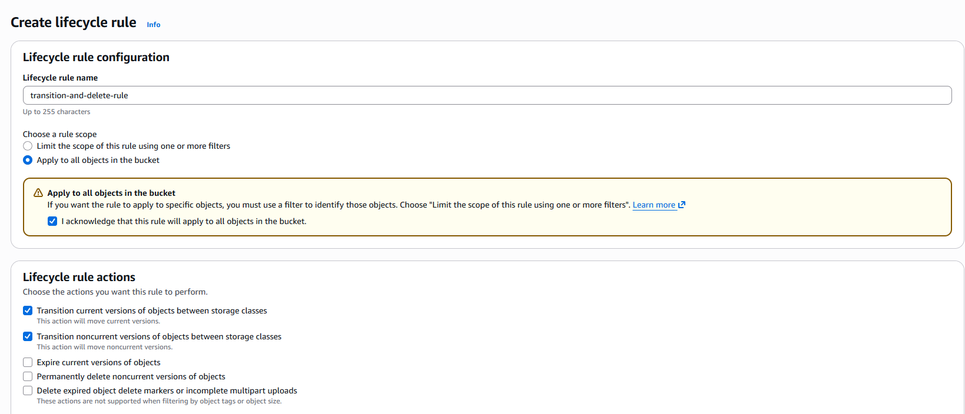
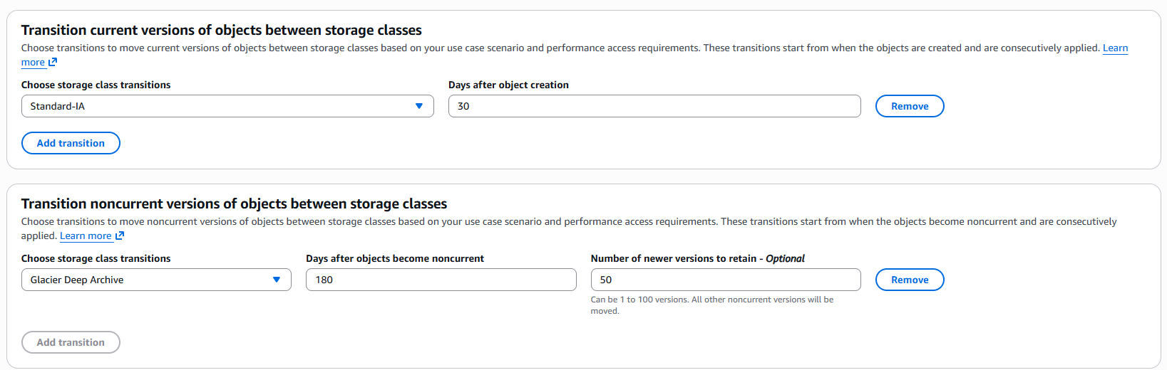
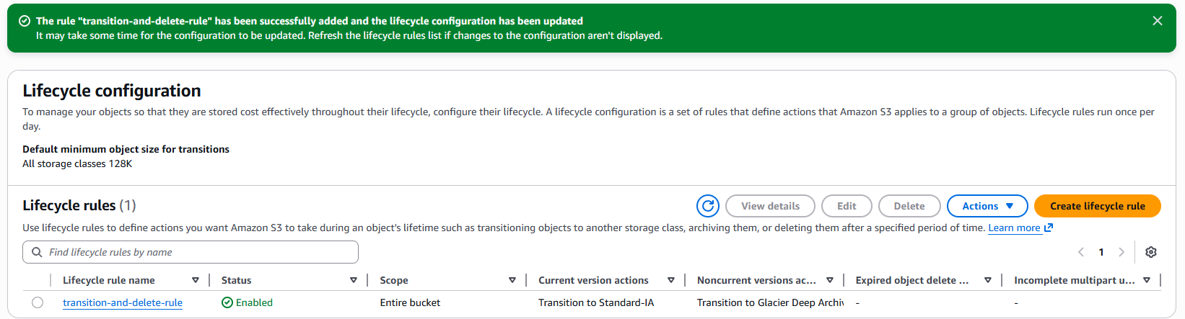

- Push some objects to S3 using the AWS CLI.
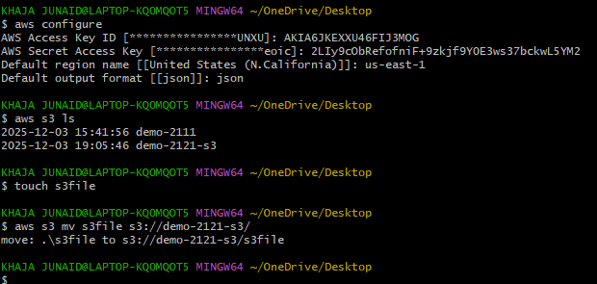
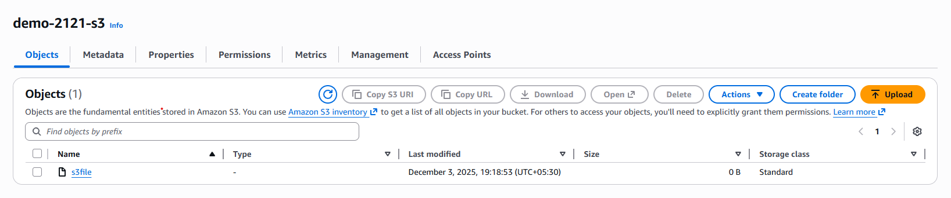

- Write a Bash script to create an S3 bucket.
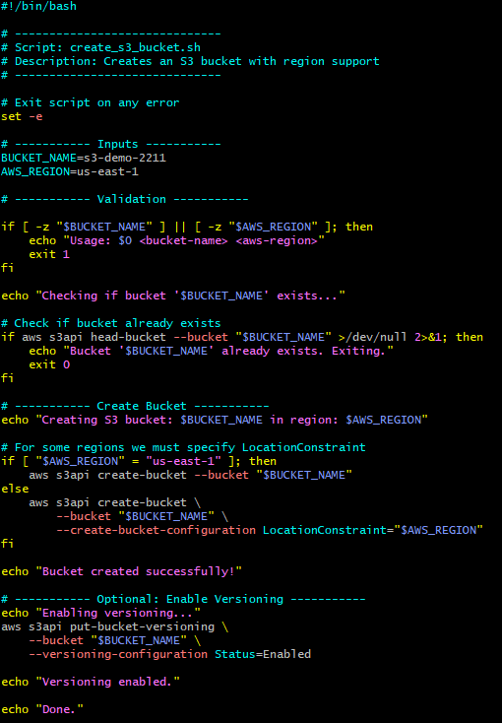
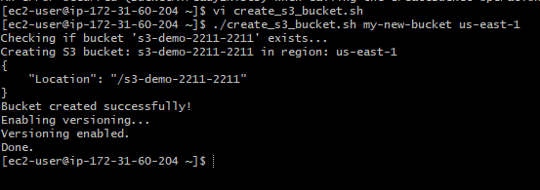
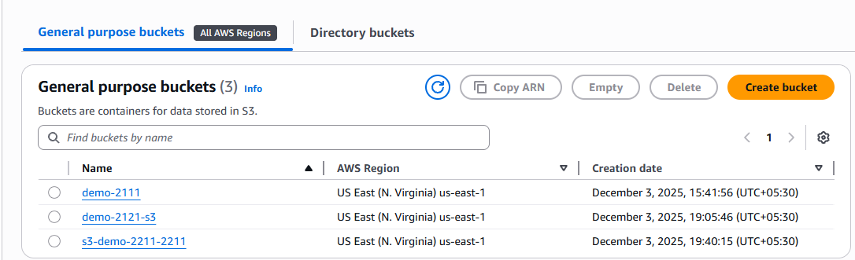

- Upload a 1 GB file to S3 using the CLI.

